NAVFIT98A Troubleshooting Guide

1. Block 15 does not auto populate when block 10 (periodic) is selected and/or the following error message is received: *Could not find file C:\Program Files\NavFit98A\Data\nf98a_dte.accdb.* Go to Problem

2. The following error message is received when attempting to open a database: *The Microsoft Office Access database engine cannot open or write to file.* Go to Problem

3. My summary letter breakout line on the summary report has the wrong numbers. Go to Problem

4. When attempting to save a report the following error message is displayed: *Collection was modified enumeration operation may not execute*. Go to Problem

5. When attempting to open a database the following error message is displayed: *Specified argument was out of the range of valid values. Parameter name: index*. Go to Problem

6. When attempting to save a summary letter profile the following error message is displayed: *The changes you requested to table were not successful because they would create duplicate values in the index, primary key, or relationship.* Go to Problem

7. When validating a folder or printing a summary letter the following message is displayed: *Conversion from string “ “ to type ‘integer’ is not valid.* Go to Problem

8. When opening the NAVFIT98A application the following error message is displayed- *Could not find file (file location listed).* Go to Problem

9. When opening the NAVFIT98A application the following error message is displayed: The Microsoft ACEOLEDB.12.0 provider is not registered on the local machine. Go to Problem

10. When creating a database the following error message is received: System.Runtime.InteropServices.COMException (0x80040154): Class not registered Go to Problem

11. When importing a folder or report the following error message is received: System.Data.OleDb.OleDbException (0x80004005): Operation must use an updateable query Go to Problem

12. The report does not display correctly when opening (lines in wrong location, boxes moved, etc) Go to Problem

13. Block 41/43 - Comments on Performance Issue: Lines cut-off when printing the report although NAVFIT98A shows you have not exceeded the 18 line limit. Go to Problem

**Problem:** Block 15 does not auto populate when block 10 (periodic) report is selected and/or the following error message is received.

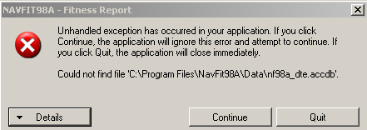

**Possible Cause:**

1. Check to see if the databases named nf98a_dte_mdb and nf98a_dte.accdb are located in following directory: C:\Program Files\NavFit98A\Data\. If not, conduct a search of your directory to find them and move the files to correct location.

2. Application does not automatically update block 15 (TO Date) if Grade/Rate is changed. You must uncheck and check Periodic block again to see the update.

**Problem:** The following error message is received when attempting to open a database.

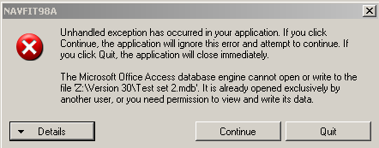

**Possible Cause:** The user does not have the correct security permissions to the folder or file. A NAVFIT98A user must have at a minimum Read/Write permissions to a database.

**Icon: WinXPTo set, view, change, or remove file and folder permissions** **for Windows XP**

1. Open Windows Explorer, and then locate the file or folder for which you want to set permissions. To open Windows Explore click **Start**, point to **All Programs**, point to **Accessories**, and then click **Windows Explorer**.
2. Right-click the file or folder, click **Properties**, and then click the **Security** tab as shown in figure below.

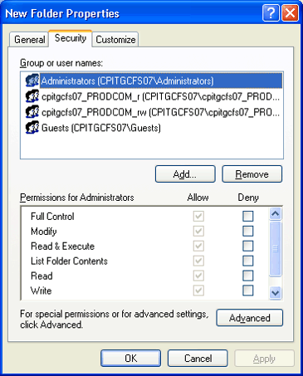

**Icon: Windows VistaTo set, view, change, or remove file and folder permissions** **for Windows Vista**

1. Right click on the folder which you want to block from other users and select Properties.

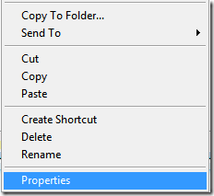

2. Now click the Security tab in the folder properties window, and then click the Edit button.

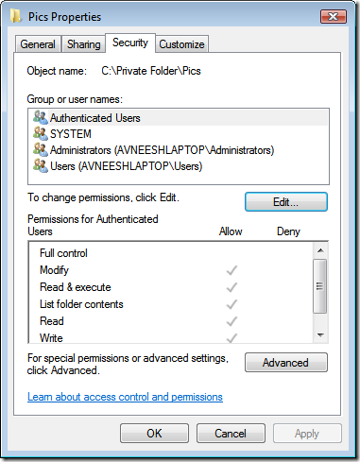

3. Select Group or user and click **Edit**

**Icon: Windows 7To set, view, change, or remove file and folder permissions** **for Windows 7**

**1.** Right click on desired folder/file. A pop-up or menu will appear. Click “Properties” option from the pop-up menu.

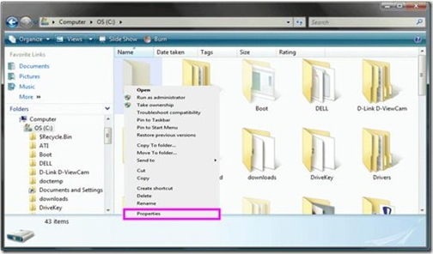

2. For permission change, select “Security tab ->Edit “button.

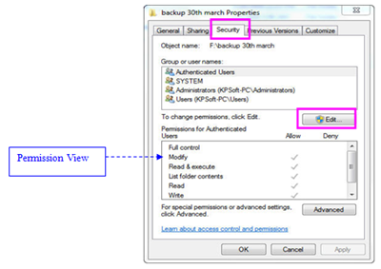

***Note:*** For permission view, Choose desired group or users from the list in current window. As you will scroll through the Group or user names list, allocated permission to authenticated user will be seen .Permission allocated may vary from user to user or group to group.

3. After the **Edit** button press, Permission for particular folder will appear. You can grant suitable permissions to desired user account. You can allow or deny rights by checking and un-checking permission options.

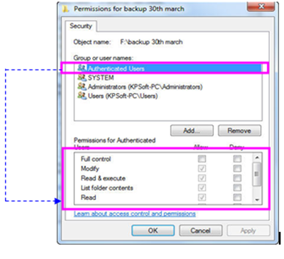

4. Press **Apply** and then press on **OK**.

5. Repeat the steps if you require different values for permission change.

**Problem:** My summary letter breakout line has the wrong numbers.

**Possible Cause:** You imported or deleted report(s) and did not open a report first before printing the summary letter. The application will not recalculate the numbers until a report is opened and saved.

**Problem:** When attempting to save a report the following error message is displayed: Collection was modified enumeration operation may not execute.

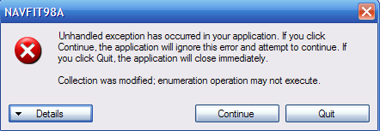

**Possible Cause(s):**

The application did not install or the workstation is not compatible. Both of these issues (installation and compatibility) are related to the .Net Framework 4.0 that is part of the NAVFIT98A installation package. First, verify that your workstation meets the hardware and operating system requirements need for .Net Framework 4.

Hardware Requirements:

Processor: minimum 1GHz

RAM: minimum 512 MB

Disk space: 32 bit-850 GB

64 bit-2 GB

Operating Systems:

All Windows 7 Editions

All Windows Vista Editions

Windows XP Professional

Windows XP Professional x64 Edition

Windows XP Home Edition

If your workstation meets these requirements then uninstall and re-install the application.

**Problem:** When attempting to open a database the following error message is displayed.

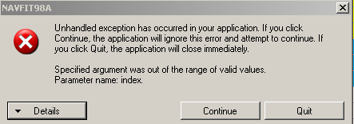

**Possible Cause:** Database is corrupted contact PERS-32 for assistance

**Problem:** When attempting to save a summary letter profile the following error message is displayed: *The changes you requested to table were not successful because they would create duplicate values in the index, primary key, or relationship.*

**Possible Cause:** You failed to enter a name in the Select Profile block.

**Problem:** When validating a folder or printing a summary letter the following message is displayed: *Conversion from string “ “ to type ‘integer’ is not valid.*

**Possible Cause:** There are null entries in the promotion summary line (block 43 or 46). Open the report and put in a promotion recommendation then close and save the report.

**Problem:** The following error message is displayed when opening the application.

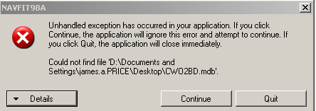

**Possible Cause:** The last database that you were using was either deleted or moved to another location. Ignore the error message and click the **Continue** button. When this action is taken the error message will disappear and the application will have no database open as shown in the below example. You can prevent this error message by closing the database currently in use prior to exiting the application.

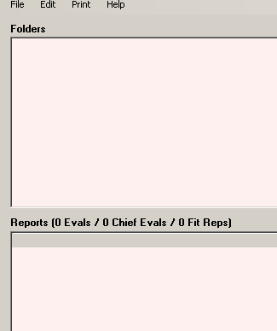

Database path is null

**Problem:** The following error message is received when opening a database.

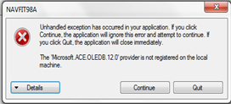

**Possible Cause**: The workstation is a full-on 64-bit system (Windows 7 with Office 2010) and it does not t have any of the 32-bit connectivity components.

To download the correct driver, take the following steps:

1) navigate to the Microsoft site - <http://www.microsoft.com/download/en/confirmation.aspx?id=23734>

2) download the 2007 Office System Driver: Data Connectivity Component and save the file to your computer

3) double-click the "AccessDatabaseEngine.exe" program file from your chosen storage location on your computer

4) follow the on-screen Microsoft installation instructions

5) upon successful installation, you will need to reboot the computer before attempting to launch NAVFIT98A

**Problem:** When creating a database the following error message is received: *System.Runtime.InteropServices.COMException (0x80040154): Class not registered*

**Possible Cause**: The workstation is a full-on 64-bit system (Windows 7 with Office 2010) and it does not t have any of the 32-bit connectivity components.

To download the correct driver, take the following steps:

1) navigate to the Microsoft site - <http://www.microsoft.com/download/en/confirmation.aspx?id=23734>

2) download the 2007 Office System Driver: Data Connectivity Component and save the file to your computer

3) double-click the "AccessDatabaseEngine.exe" program file from your chosen storage location on your computer

4) follow the on-screen Microsoft installation instructions

5) upon successful installation, you will need to reboot the computer before attempting to launch NAVFIT98A

**Problem:** When importing a folder or report the following error message is received: System.Data.OleDb.OleDbException (0x80004005): Operation must use an updateable query

**Possible Cause**: This error comes because you don't have write permission for the folder where you have put mdb file. Give the appropriate permission and try again.

**Problem:**  The report does not display correctly when opening (lines in wrong location, boxes moved, etc)

**Possible Cause:** Unknown but the following steps will fix it.

1. Select/click 'Start' menu

2. Select/click 'Control Panel'

3. Select/click 'Appearance and Personalization'

4. Select/click 'Display'

5. At the left side of the screen, select/click 'Set custom text size (DPI)'

Once the 'Custom DPI Setting' screen appears:

1. Select the 'Use Windows XP style DPI scaling' located at the bottom of the screen window

2. Select/click 'OK'

3. Close all of the programs

4. Log off and reboot the machine

5. Logon and attempt to launch NAVFIT98A following successful reboot

**Problem:** WYSIWYG (What You See Is What You Get) does **not** apply due to the issue. It will **appear** that you can have **92 characters** per line available on the NAVFIT98A screen display, but when you **PRINT** out the report, lines that have 92 characters will have the last word move to the next line. This situation happens because NAVFIT98A allows **18 lines maximum, 91 characters** (including punctuation and spaces) per line with **10-Point font when the report is printed.**

**WORD TEMPLATE SETUP: COURIER NEW 10 PITCH. MARGINS: L = 0.4”/R = 0.5”**

**Note:** **Margins have been preset for this page.** If you copy and paste your text from Block 41/43 onto Line 1 below, you can use this as a template for line spacing and margins, and you will also be able to view misspelled words that are underlined in **Red**. “Continuous Line Numbers” has been activated in Word. (You can also tell how many lines and spaces are used by highlighting the text and clicking on bottom left of screen on status bar, where it shows word count, and a popup will give you the number of lines/spaces used.)